**SCHOOL NETWORK DESIGN HOME LAB**

**USING CISCO PACKET TRACER**

**Network Design Home Lab**

**Date: October 4, 2023**

**Overview**

**This report details the network design for a home lab with the given network address 10.3.99.0 The network is divided into 6 subnets as follows:**

|  |  |  |  |  |  |
| --- | --- | --- | --- | --- | --- |
| **Subnet Name** | **Subnet Mask** | **Subnet Address** | **Default Gateway** | **Broadcast Address** | **Usable Host Range** |
| **Admissions** | **255.255.255.224** | **10.3.99.0** | **10.3.99.1** | **10.3.99.31** | **10.3.99.2 - 10.3.99.30** |
| **Administration** | **255.255.255.224** | **10.3.99.32** | **10.3.99.33** | **10.3.99.63** | **10.3.99.34 - 10.3.99.62** |
| **Faculty** | **255.255.255.224** | **10.3.99.64** | **10.3.99.65** | **10.3.99.95** | **10.3.99.66 - 10.3.99.94** |
| **Student** | **255.255.255.224** | **10.3.99.96** | **10.3.99.97** | **10.3.99.127** | **10.3.99.98 - 10.3.99.126** |
| **Housing** | **255.255.255.224** | **10.3.99.128** | **10.3.99.129** | **10.3.99.159** | **10.3.99.130 - 10.3.99.158** |
| **Library** | **255.255.255.224** | **10.3.99.160** | **10.3.99.161** | **10.3.99.191** | **10.3.99.162 - 10.3.99.190** |

**Subnet Designs**

**The Administration and Housing subnets each contain 2 computers and 1 DHCP server.**

**The Admission contain 2 computers and 2 servers (DHCP and FTP)**

**The Faculty subnet contains 1 server, 2 laptops, and 4 computers.**

**The Student subnet contains 1 computer, 1 DHCP server supporting up to 20 devices, and 10 laptops.**

**The Library subnet contains 2 computers, 1 wireless router with 4 wireless devices.**

**All servers are assigned the last usable IP address in each subnet. All computers are assigned the first usable IP address. The wireless router is assigned the last usable IP address.**

**ACL Implementation**

**The ACLs were enabled and tested by pinging from a wireless device in the Library subnet to verify connectivity, then lack of connectivity when ACLs enabled, and restored connectivity when ACLs disabled.**

**4 ACLs were created:**

**- ACL 20 blocks Admissions servers - ACL 30 blocks Administration servers**

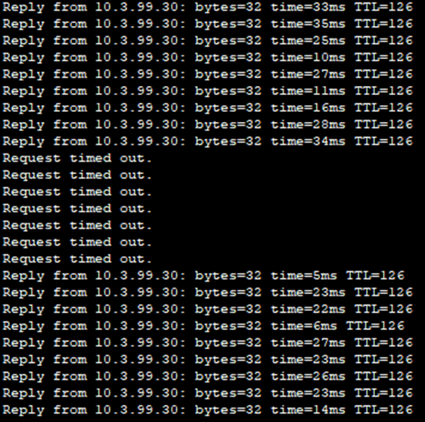

**The network was designed and configured according to the provided specifications. Connectivity testing validated the configuration and ACL implementations. Further optimization or changes to the design can be implemented as required.**

**Network Topology Diagram**

**[packet tracer topology diagram screenshot]**

**Device Configurations**

**Admissions Subnet:**

**Server (FTP): 10.3.99.29**

**Server (DHCP): 10.3.99.30**

**Computer 1: 10.3.99.2**

**Computer 2: 10.3.99.3**

**Administration Subnet:**

**Server (DHCP): 10.3.99.62**

**Computer 1: 10.3.99.34**

**Computer 2: 10.3.99.35**

**Faculty Subnet:**

**Server: 10.3.99.94**

**Laptop 1: 10.3.99.67**

**Laptop 2: 10.3.99.68**

**Computer 1: 10.3.99.66**

**Computer 2: 10.3.99.69**

**Computer 3: 10.3.99.70**

**Computer 4: 10.3.99.71**

**Student Subnet:**

**Server (DHCP): 10.3.99.126**

**Computer: 10.3.99.107**

**Laptop 1: 10.3.99.98 | Laptop 6: 10.3.99.103**

**Laptop 2: 10.3.99.99 | Laptop 7: 10.3.99.104**

**Laptop 3: 10.3.99.100 | Laptop 8: 10.3.99.105**

**Laptop 4: 10.3.99.101 | Laptop 9: 10.3.99.106**

**Laptop 5: 10.3.99.102 | Laptop 10: 10.3.99.108**

**Library Subnet: Housing Subnet:**

**Computer 1: 10.3.99.162 Server (DHCP): 10.3.99.158**

**Computer 2: 10.3.99.163 Computer 1: 10.3.99.130**

**Wireless Router: 10.3.99.190 Computer 2: 10.3.99.131**

**Wireless Device 1: DHCP assigned.**

**Wireless Device 2: DHCP assigned.**

**Wireless Device 3: DHCP assigned.**

**Wireless Device 4: DHCP assigned.**

**CONNECTION TEST**

**PINGING EACH DEVEICES**



